**Project Initialization and Planning Phase**

| Date | July 2024 |
| --- | --- |
| Team ID | 739678 |
| Project Name | Zombie detection using the machine learnig |
| Maximum Marks | 3 Marks |

### Define Problem Statements(zombie detection Statement Template):

Create a problem statement to understand your users point of view. The zombie detection Problem Statement template helps you focus on what matters to create experiences peoplewill love. A well-articulated prediction problem statement allows you and your team to find the idealsolution for your customers' challenges. Throughout the process, you’ll also be ableto empathize with your prediction, which helps you better understand how they predict the human or zombie

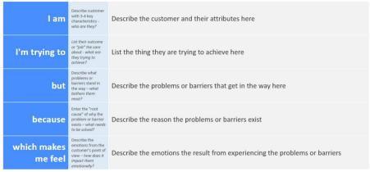

Reference: https://miro.com/app/board/uXjVK2aqlmY=/?share_link_id=534024970903

| **Problem**  **Statement (PS)** | **I am** | **I’m trying to** | **But** | **Because** | **Which makes me feel** |
| --- | --- | --- | --- | --- | --- |
| PS-1 | human | Predict the qualities of zombies | The prediction is not accurate | The system doesn't account for real-time predicting | Anxious and dissatisfied |
| PS-2 | zombie | make sure the prediction predicts the correctly | the prediction estimates are often off | the system doesn’t account in unisco login | Angry and the scary |